**Basline Deliverables in Document Control**

**Module Description**

In this current phase of the project, you will learn if you have received signoff on the product test based on the Test Closure Memo results.

**Time Warp Presentation**

Click the link to launch the [Module 39 Time Warp Presentation](https://accenture.desire2learn.com/content/enforced/9406-Pending/W4_Participant_Materials/Module_39/ADF_2_0_Java_M39_TimeWarp_PD.pptx?_&d2lSessionVal=YnoL4daZGC8ne2RyGf0cWMrk8).

**Scenario**

The project team has successfully completed the product test and now it is time to Transition the Product-Tested Application. You and the team will be asked to make sure all of the latest code and documents have been placed in the relevant code and document repositories.

The Team Lead will designate which team members will review which parts of the deliverables. The application and application work products need to be checked to ensure they are ready for review by the UAT team.

**NOTE:** Although this is an activity typically performed by the testing team, your team will be doing this because members of the UAT team have being rolled off to reduce project costs.

**ADM Activity Context Diagram**

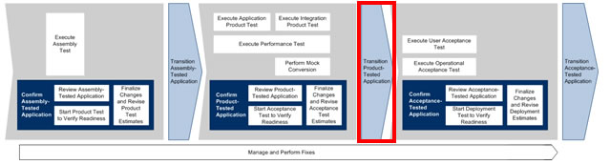

**Roles**

|  |  |  |  |
| --- | --- | --- | --- |
| **Role** | **ADM Task** | **ADM Responsibility** | **Description** |
| Team Lead | T5749 Transition Product-Tested Application | Primary Performer | Reviews the Application Build Deliverables using the Application Build Checklist. |
| Developer | T5749 Transition Product-Tested Application | Primary Performer | Confirms that all the work products are in the appropriate code or document repository. |

**Participant Instructions**

1. Using the [JavaDoc with No Comments (Zip File)](https://accenture.desire2learn.com/content/enforced/9406-Pending/NCCC_Project_Work_Products/3b_App_Design/Release_1/JavaDocs/JavaDoc_withNoComments_FERS_R1_REF.zip?_&d2lSessionVal=YnoL4daZGC8ne2RyGf0cWMrk8) as reference:

a. Identify all of the documents that were changed as part of the product test and their appropriate versions.

b. Make sure all updated documents are checked into the document repository.

c. Identify all of the code that changed during the Product Test and the appropriate version numbers.

d. Make sure all code is checked into the code repository.